A TEMPLATE FOR FULL PAPER OF 2016 USU SEMINAR

Author Name 1*, Author Name2 and Author Name3

1Faculty, University, City following by Post Code

2Research Centre, University, City following by Post Code

3Company, City following by Post Code

*Corresponding author: (email)

**ABSTRACT**

The paper should follow as much as possible this template to facilitate easy reading and consistency. Provide an abstract of not more than 250 words including background, objectives, methodology, research results and conclusions of your study. The abstract should be informative, summarizing the main findings. The page limit is 8 pages. If paper length exceeds the maximum limit or if the final paper is not according to this Template – it may not be published in the printed proceedings. Please double check that 12 font size throughout the paper except the title which is 14 font sizes only. Follow the style given above. This seminar is free in charge, however authors who need the printed proceedings, they must contribute IDR 50,000 per book. The contribution must pay on 18th August 2016 or 1st day of the seminar. Visit website for any update.

Keywords: Template, USU seminar, limit, no more than five keywords

# 1. INTRODUCTION

Papers should clearly describe the background of the paper, the methods used, results and discussion as well as concluding remarks on the importance of the paper and future research. Papers are to be prepared in English or Bahasa Indonesia.

The paper is to be printed on an A4 paper. The margins are 2.5 cm for all side as in this template. Use 12 point Times New Roman font except the title which is 14 font sizes only. Single line spacing is mandatory. All text should be left and right justified. Throughout the paper including text inside figures and tables must follow 10 Font size or no more than 12 Font size. Please do not insert page numbers (the editors will insert these).

It is expected that authors submit carefully written and proofread papers. Spelling and grammatical errors, as well as other language problems, should be avoided. The paper length should not exceed eight (8) pages. Please save to MS Word templates directory.

# 2. HEADINGS

A uniform outlook will help the readers to follow the proceedings. Use no more than three levels of headings that correspond to chapters, sections and subsections. The first level headings for chapter titles should be in 12pt, bold, justified, and upper case font. Insert one blank line before the headings and between paragraphs.

**2.1. The Second Level Headings**

The second level headings should be in 12pt, bold, justified, and capitalized font in first character. Insert one blank line before the headings.

**2.2. The third level headings**

The third level headings should be in 12pt, regular, justified, and sentence case. Insert one blank line before the headings. The further lower level headings should be avoided.

# 3. tables, figures and plates

Use 12pt for table, figure and plate captions, as shown in Table 1, Figure 1 and Plate 1. Do not leave a blank between table/figure/plate and their caption. Table, figure and plate captions should be self explanatory without having to refer to the text. It is suggested that all text within tables, figures and plate be not smaller than 10pt. Insert one blank line before the table caption or after the figure and plate captions.

Table 1: Caption of an example of table

|  |  |  |  |
| --- | --- | --- | --- |
| Items | X | Y | Z |
| A | 3 | 5 | 7 |
| B | 4 | 2 | 2 |
| C | 2 | 1 | 3 |

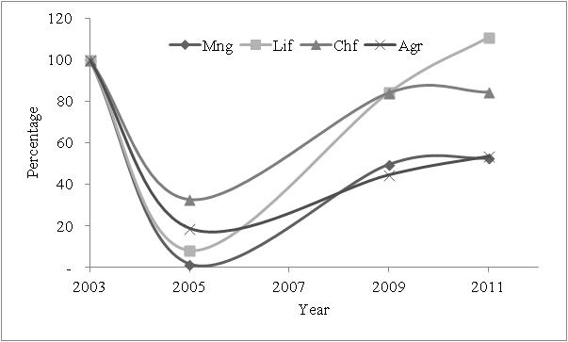

Figure 1: Caption of an example of figure

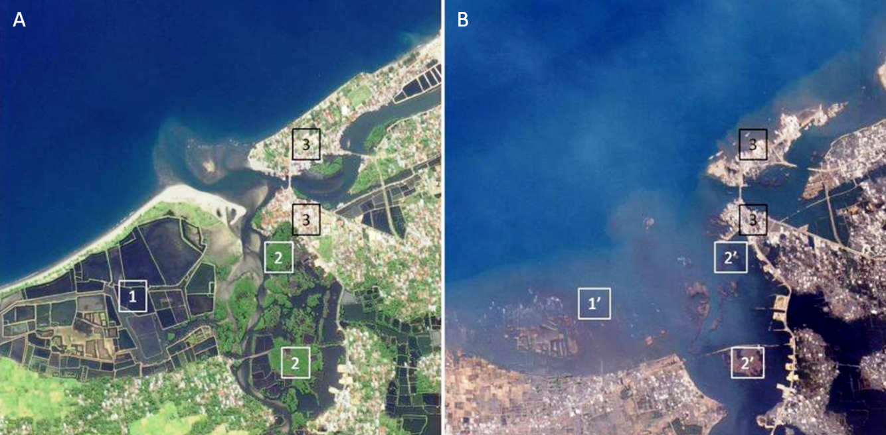

Plate 1: Caption of an example of plate

Tables, figures and plates should be placed close after their first reference in the text. All figures and tables should be numbered with continuous Arabic numerals. Table headings should be justified above the tables. Figure and plate captions should be justified below the figures and plates. Do not place any text besides the tables, figures or plates. Do not place them altogether at the end of manuscripts. Tables, figures and plates not cited in the text should not be presented.

You may use color figures and plates in your paper. These will appear in color on the online version of the proceedings. However, please check that your color figures or plates are legible when printed in monochrome (black and white), as this is the way they will be reproduced in the hardcopy version of the proceedings.

# 4. equations and Symbols

Each equation should be presented on a separate line from the text with a blank space above and below. Equations should be clear and expressions used should be explained in the text. The equations should be typed in the equation editor and numbered consecutively, as shown in Equation (1) below.

 (1)

# 5. REFERENCINGS

If the authors such as Onrizal and Mansor (2016) are mentioned in the flow of the text, then only the year is required in brackets. Where the number of authors exceeds two, “et al.” should be used. An example paragraph is given below.

In this study, *Rhizophora* spp. was the strongest species as compared to other genera of mangroves. This is in concordance with the finding by Yanagisawa et al. (2010). The dense structures of prop roots of a *Rhizophora* tree that extending all around (Jayatissa et al., 2002) have contributed to the resistance of tsunami flow even in the soft ground of tidal flat. Meanwhile, other genera without prop roots were easily uprooted. Based on field survey, Dahdouh-Guebas (2006) and Tanaka et al. (2007) reported that *Rhizophora apiculata* and *Rhizophora mucronata* were especially effective in providing protection from tsunami damage due to their complex aerial root structure. References not cited in the text should not be listed. The references are 5mm hanging indentation as show in references chapter.

# 6. conclusionS

The paper should state concisely the most important conclusions, the author’s views of the theoretical or practical implications of the results as well as future research direction. Full paper must follow this pattern.

# 7. Acknowledgement

You may acknowledge anyone or organizations who have contributed to the paper at the end of the text just before the references.

8. REFERENCES

Dahdouh-Guebas, F. (2006). Mangrove forests and tsunami protection. In: 2006 McGraw-Hill Yearbook of Science and Technology, McGraw-Hill Professional, New York, USA, pp 187-191.

Jayatissa, L.P., Dahdouh-Guebas, F. and Koedam, N. (2002). A review of the floral composition and distribution of mangroves in Sri Lanka. Botanical Journal of the Linnean Society 138 (1), 29-43.

Onrizal and Mansor, M. (2016). Status of coastal forests of the Northern Sumatra in 2005 (after 2004’s tsunami catastrophe). Biodiversitas 17 (1), 44-54

Tanaka, N., Sasaki, Y., Mowjood, M.I.M., Jinadasa, K.B.S.N. and Homchuen, S. (2007). Coastal vegetation structures and their functions in tsunami protection: experience of the recent Indian Ocean tsunami. Landscape and Ecological Engineering, 3 (1), 33-45.

Yanagisawa, H., Koshimura, S., Miyagi, T. and Imamura, F. (2010). Tsunami damage reduction performance of a mangrove forest in Banda Aceh, Indonesia inferred from field data and a numerical model. Journal of Geophysical Research, 115, C06032, 1–11.